AWS setup steps

1. Create cognito user pool and setup one of app client

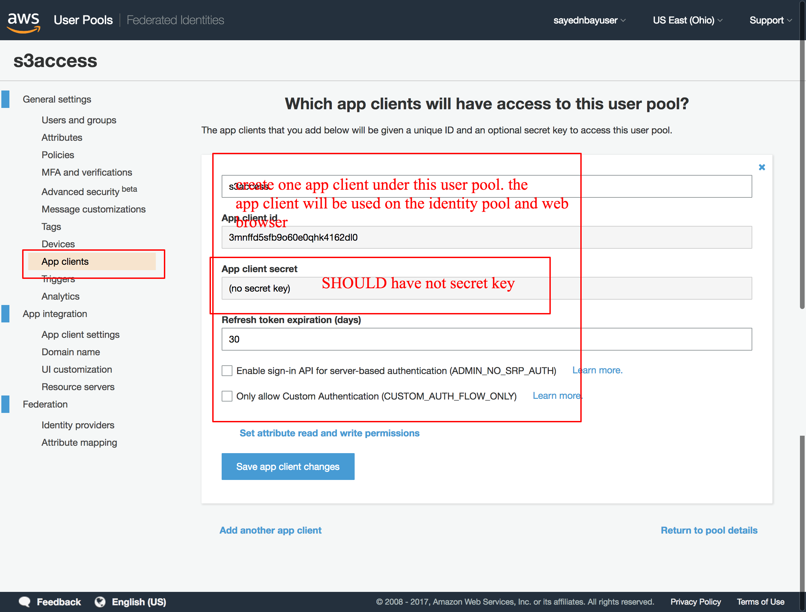

1. Create identity pool

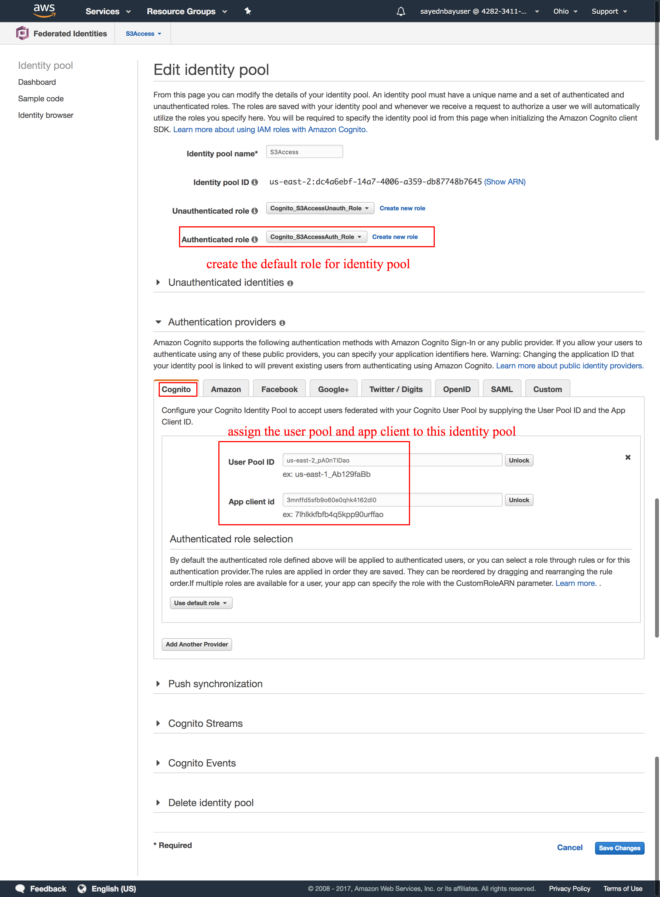

1. Create lambda function

Please make sure the lambda function have the full permissions on S3. If have not permission, please setup it via the IAM Role policy

Create a role which have full S3 permissions for the lambda function

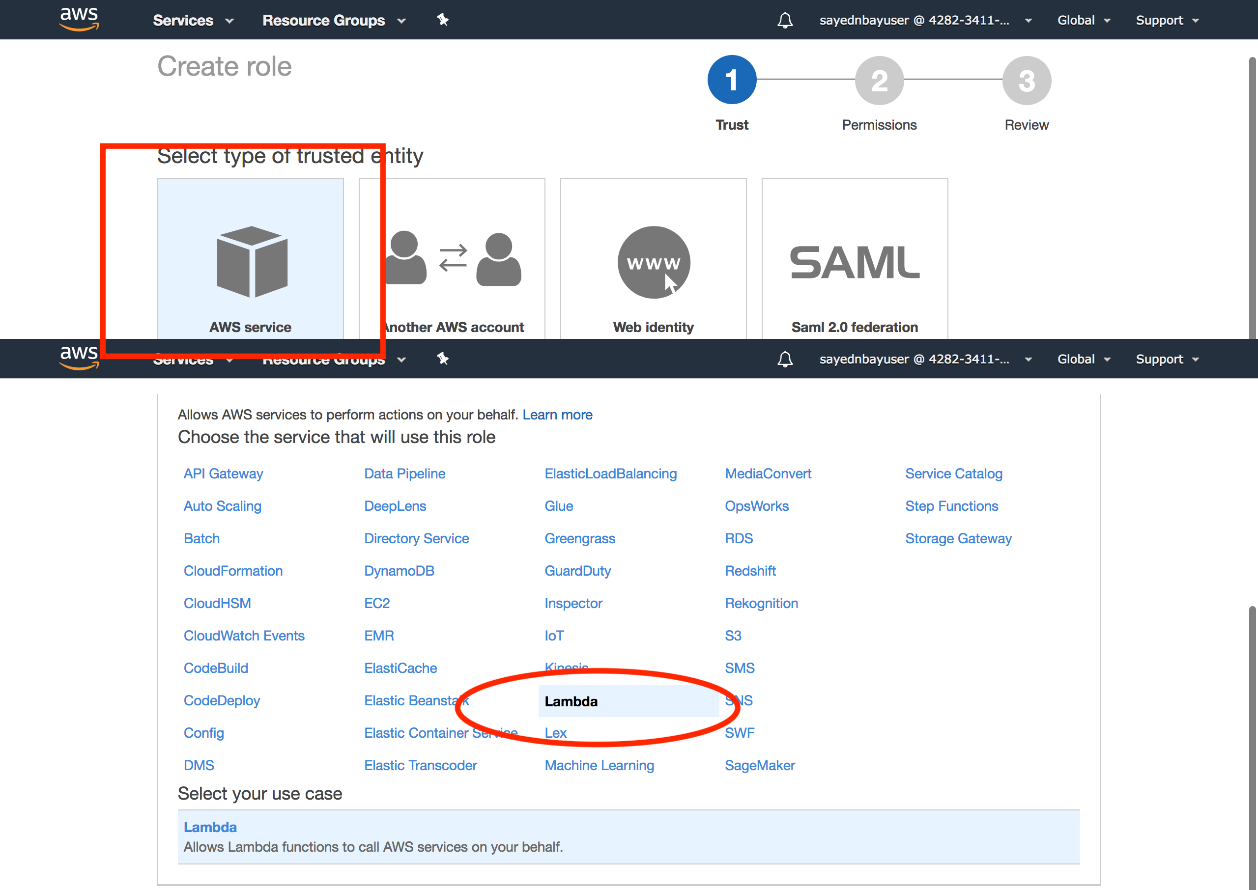

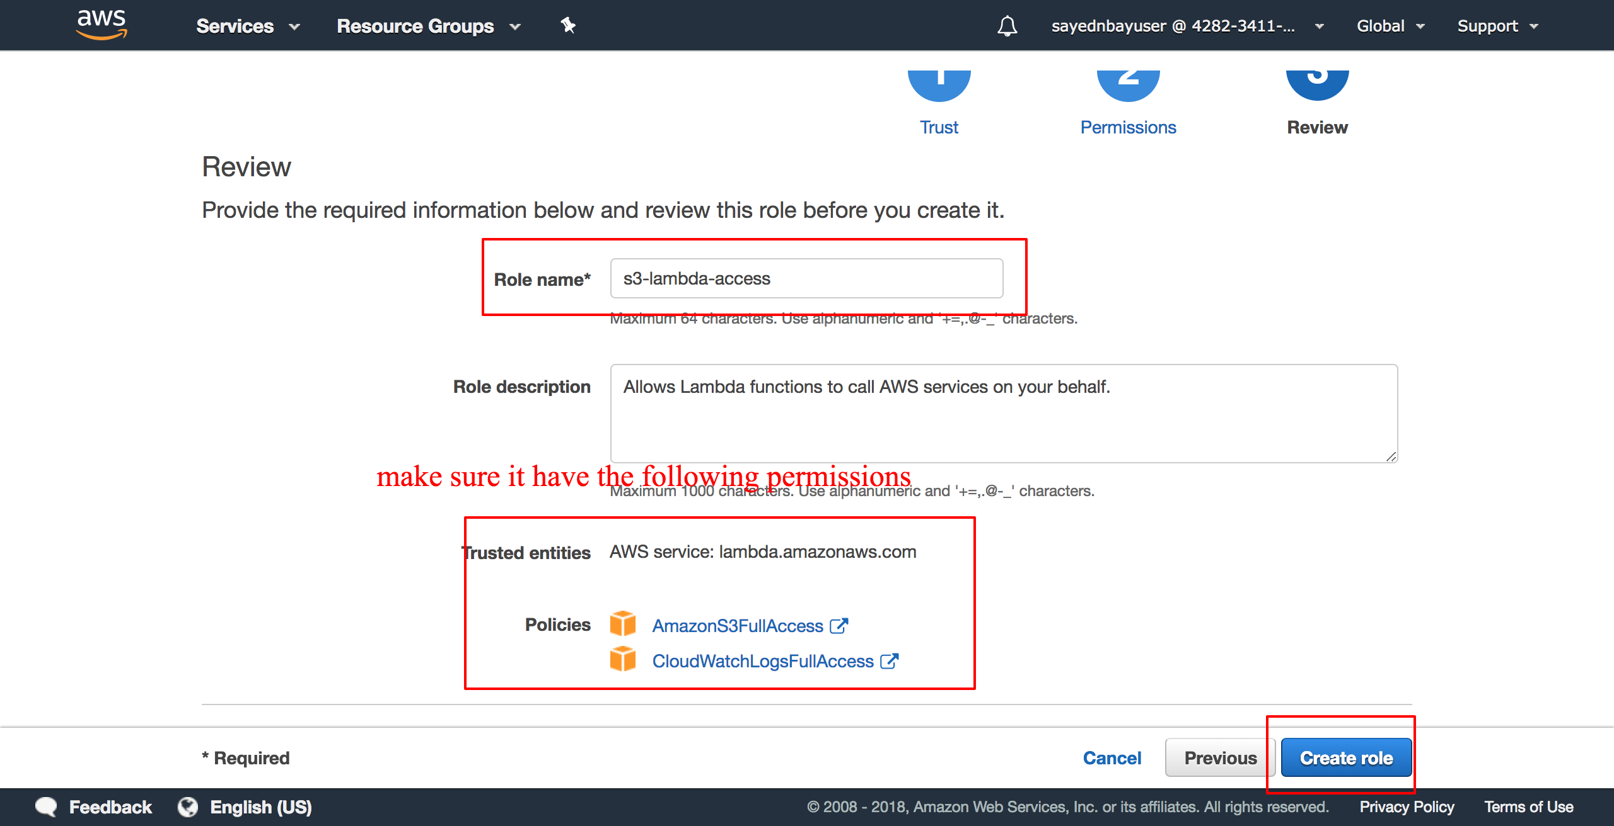

create lambda function

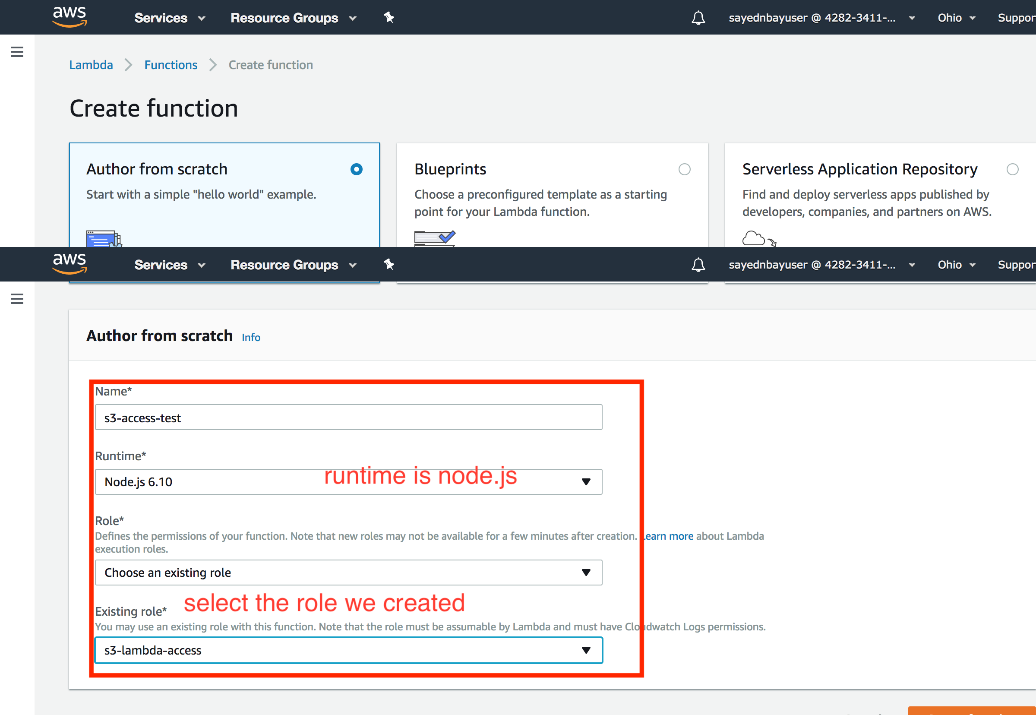

then upload from from ‘aws-s3access-lambda’ as for the lambda function

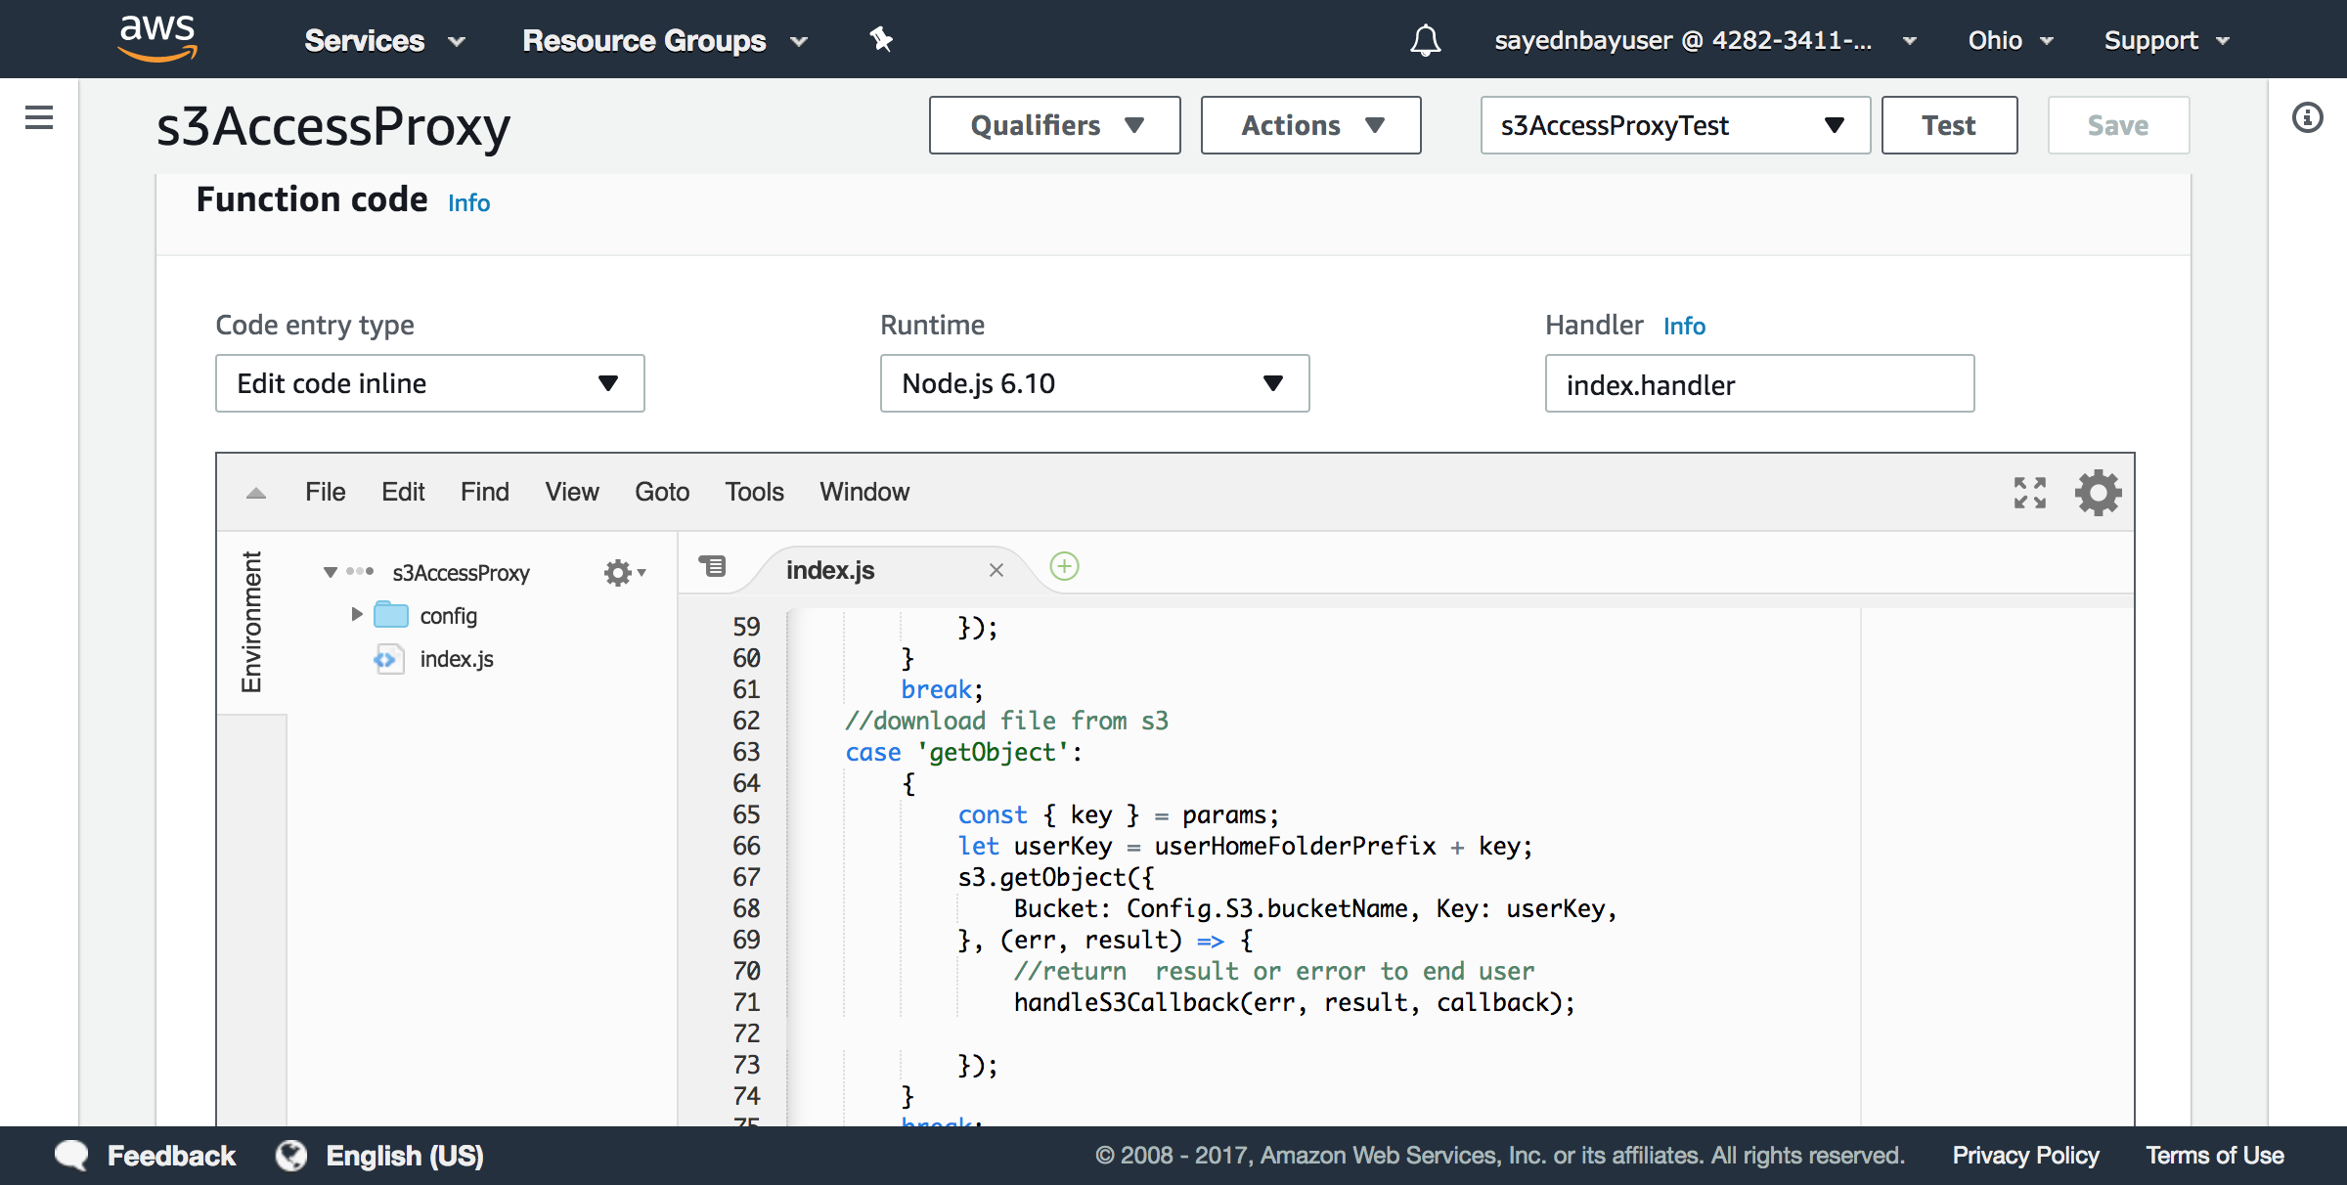

1. Create api gateway, enable COR, setup the lambda function above as proxy, setup cognito as authenication

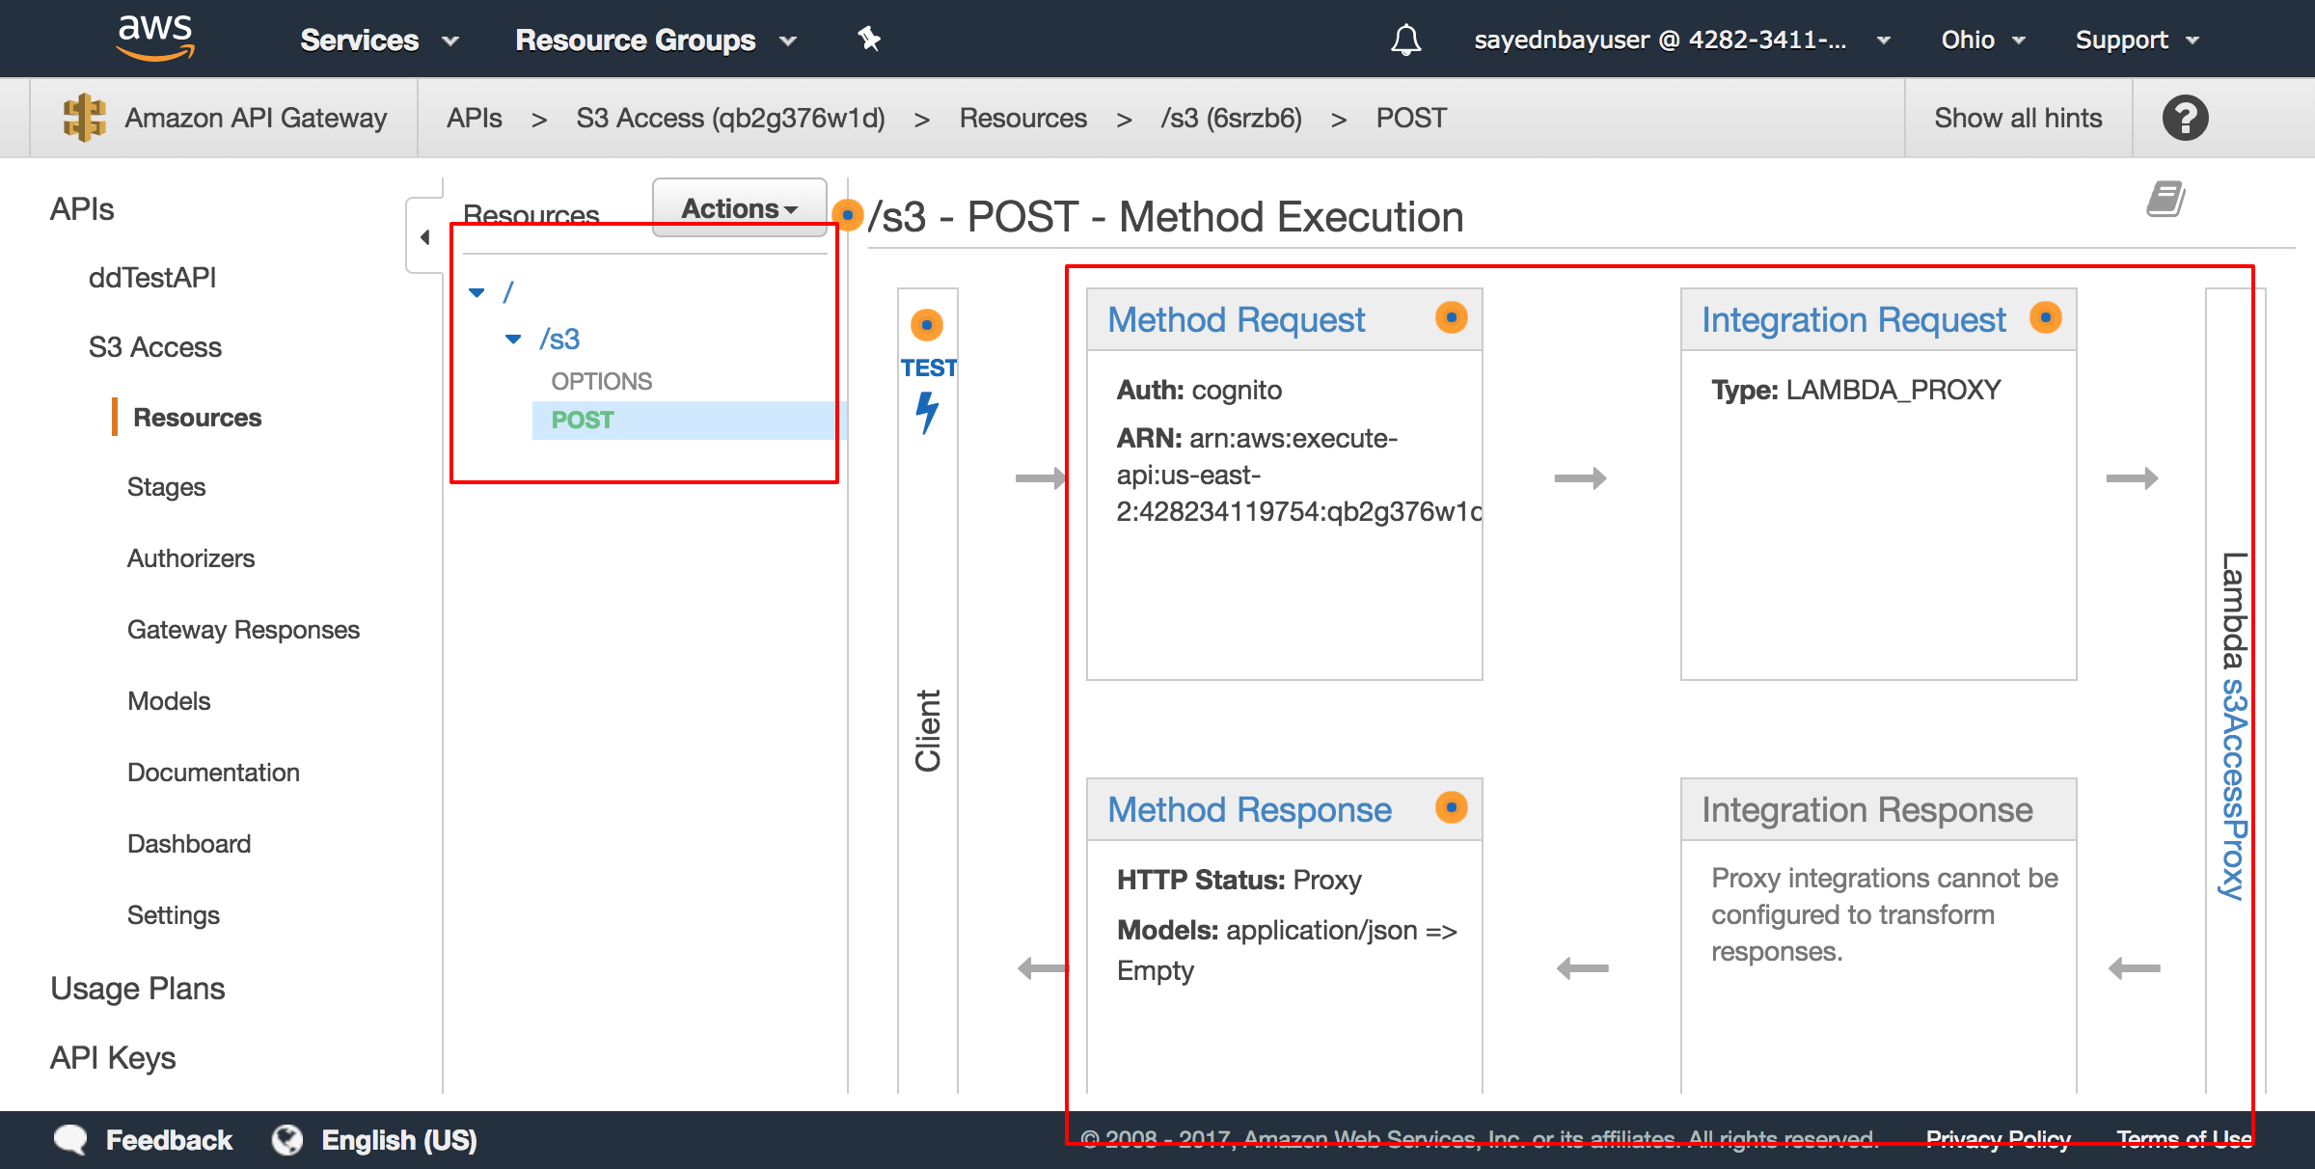

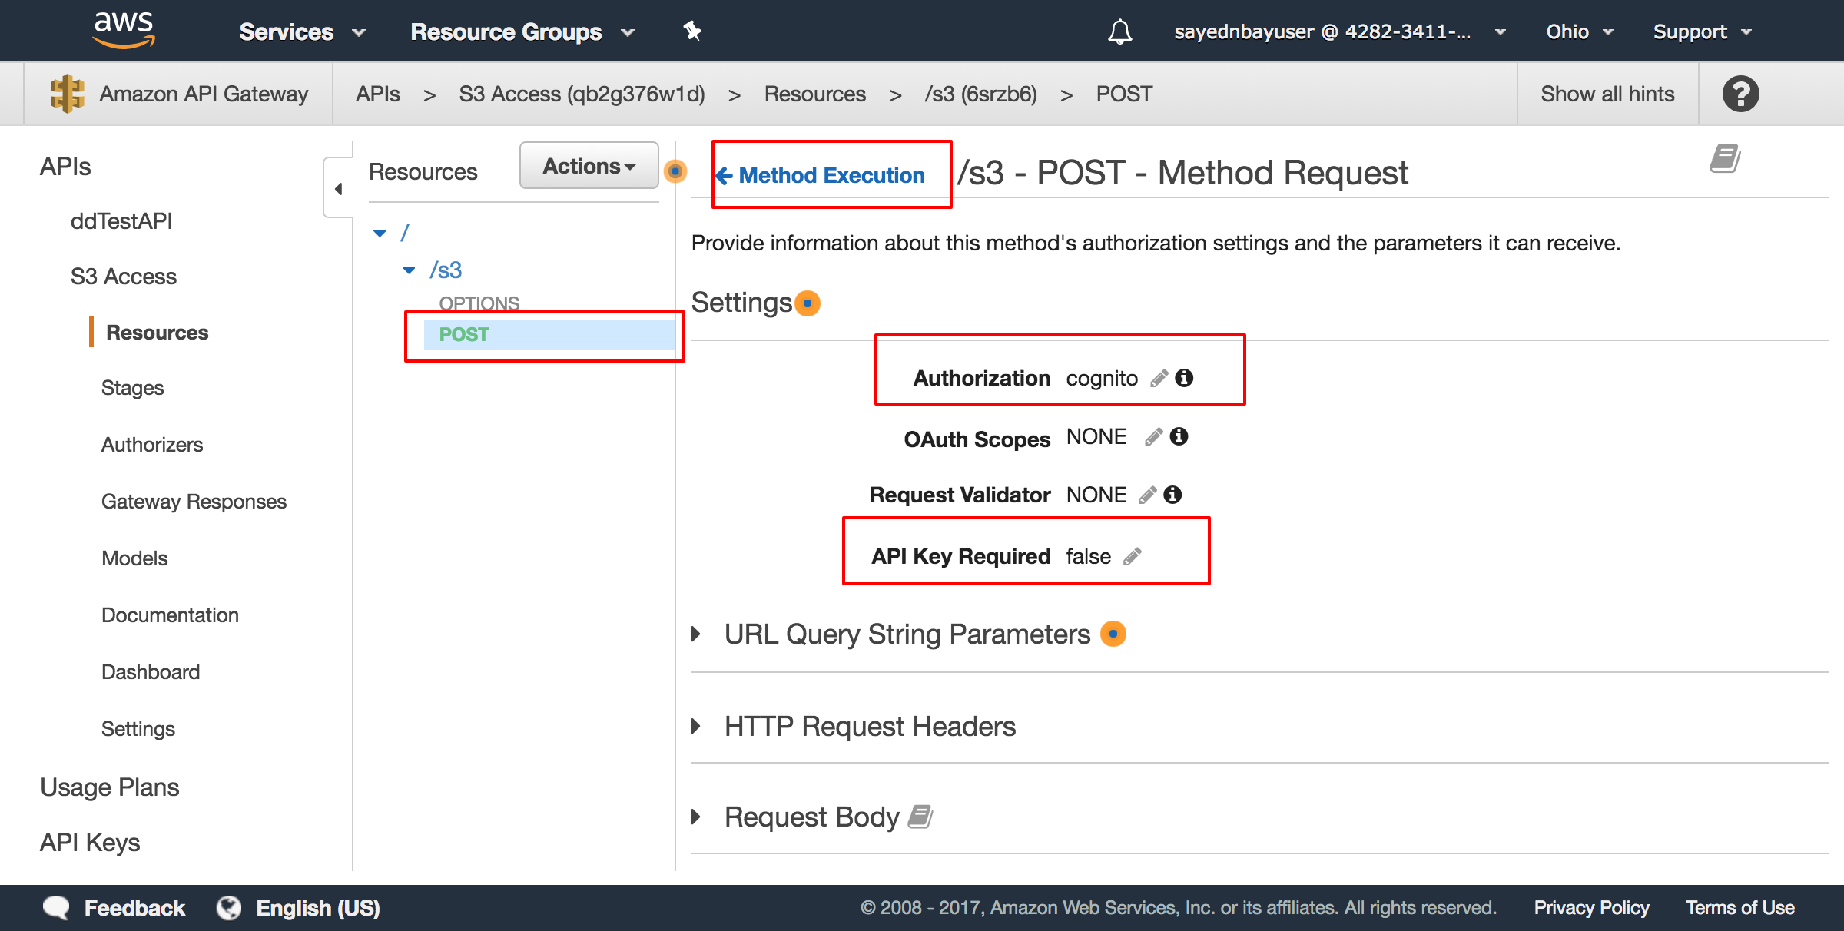

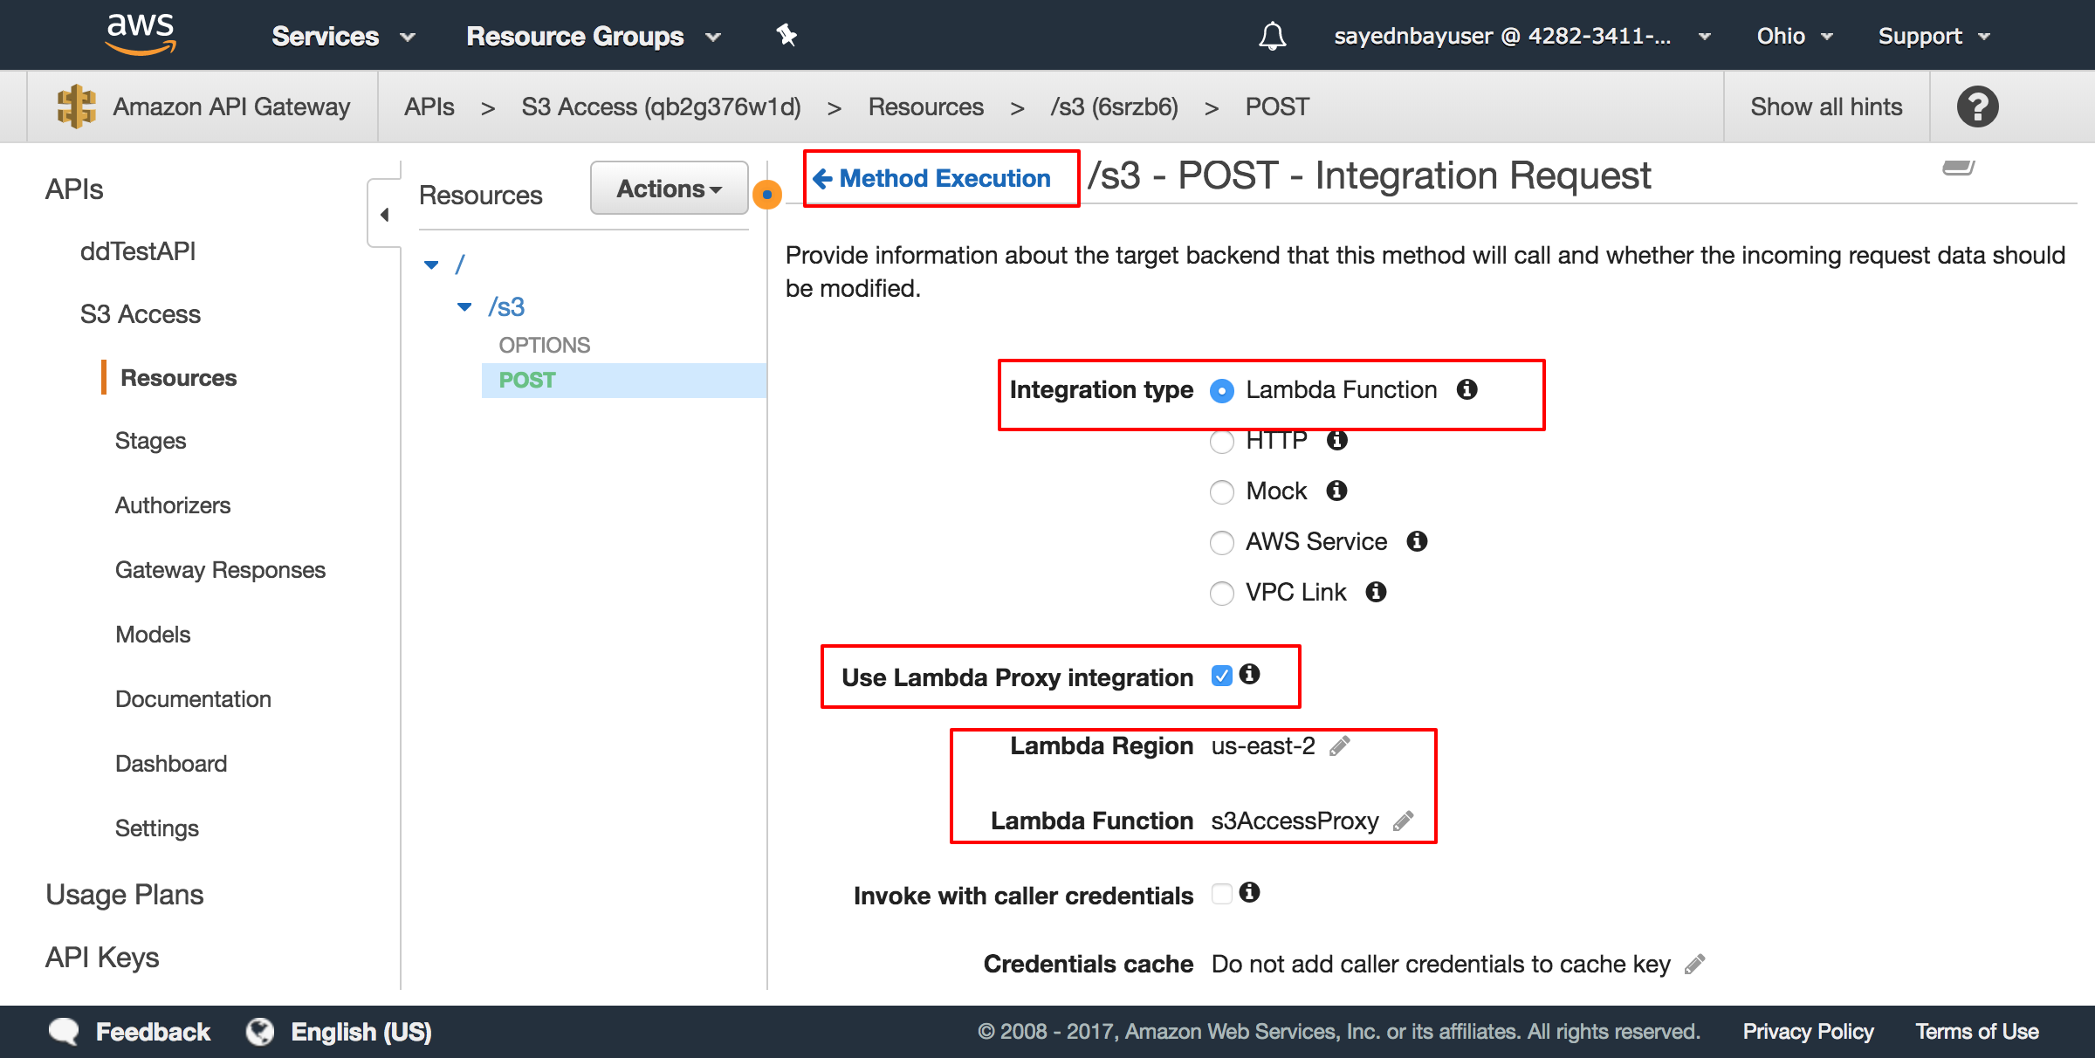

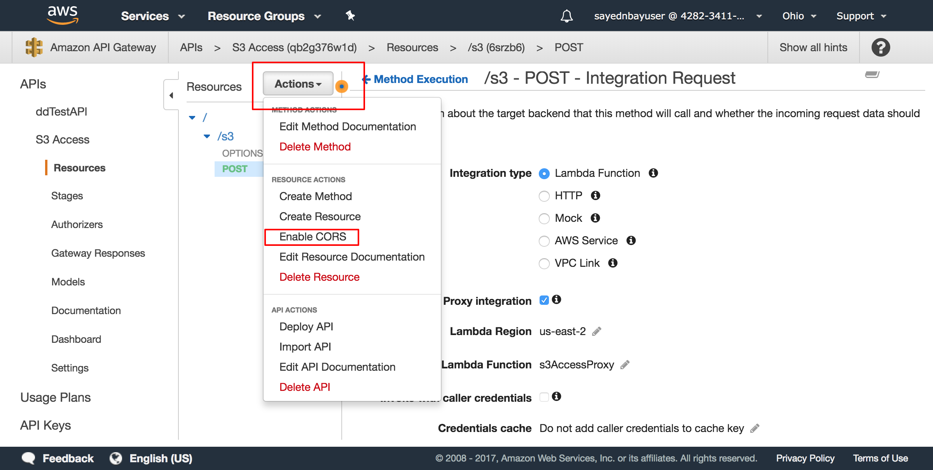

1. Deploy the API to stage

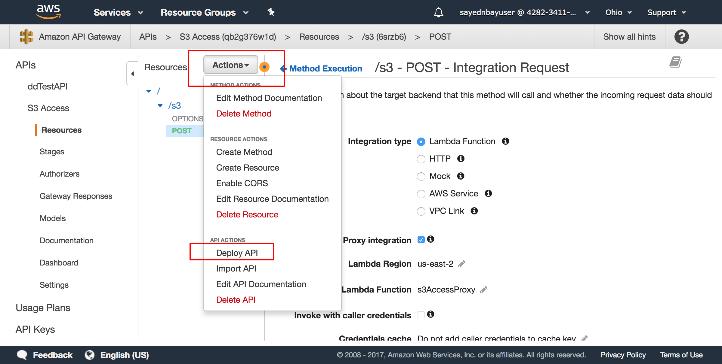

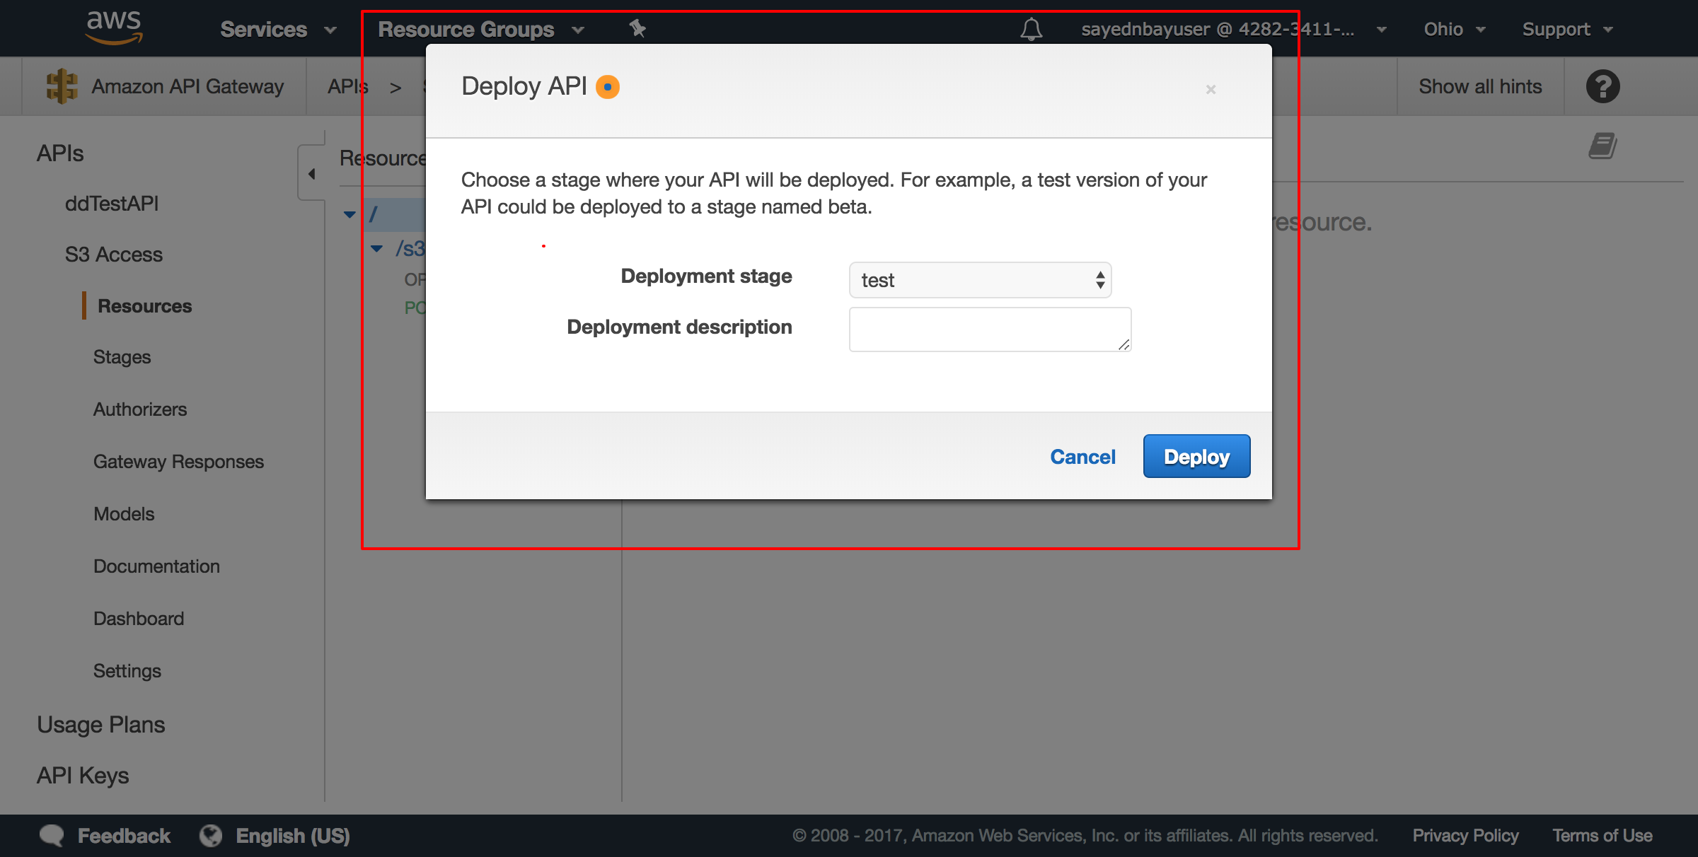

then you will find the url of api at

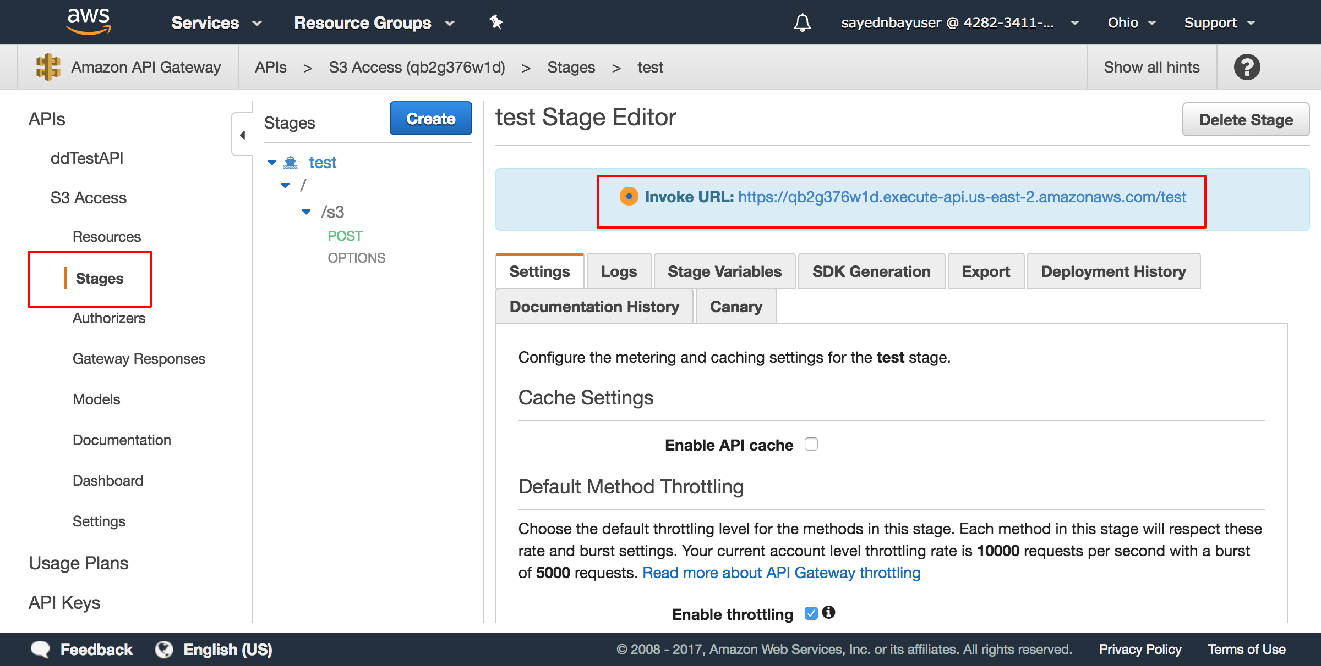

after these setup, you make some configuration at frontend and lambda function.

1. For the front end, please check file “aws-s3access-frontend/src/config/index.js”, please check the comment
2. For the lambda function, please check file “aws-s3access-lambda /config/index.js”, please the comment